CHAPTER

# 20

## CHROMOSOMES AND

DNA

*Animation 20:: Growth and development* [*Source & Credit: Wiki*](http://https://en.wikipedia.org/wiki/DNA)*pedia*

Chromosomes are thread like structures that appear inside the nucleus at the time of cell division. They were irst observed by the German embryologist Walther Fleming in 1882, when he was examining the rapidly dividing cells of salamander larvae. Since their discovery, chromosomes have been found in the cells of all eukaryotes. Their number however varies from species to species. **Pencillium,** a fungus, has only one pair of chromosomes, while some ferns have more than 500 pairs. A mosquito has 6, honeybee 32, corn 20, sugarcane 80, frog 26 and a mouse has 40 chromosomes. Human cells have 46 chromosomes, consisting of 23 pairs (Fig 20.1). Each of these 46 chromosomes contains hundreds or thousands of genes that play important roles in determining how a person’s body develops and functions. The possession of all these chromosomes is therefore, essential for survival. Missing of a part or whole of chromosome leads to serious consequences, and death occurs.

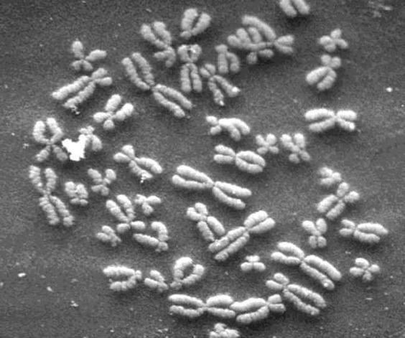

*Fig. 20.1 Human chromosomes*

**TYPES OF CHROMOSOMES**

Typically, a chromosome is made of chromatids, centromere, (primary constriction), and a secondary constriction (Fig 20.2).

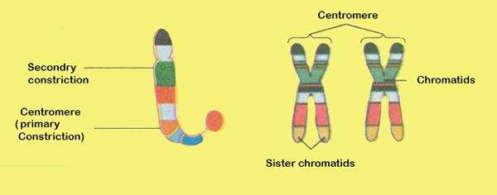

*Fig 20.2 Structure of chromosome*

Chromosomes may widely difer in appearance. They vary in size, staining properties, the location of centromere, relative length of two arms on either side of centromere, and the position of constricted regions along the arms. The particular array of chromosomes that an individual possesses is called its karyotype (Fig 20.3). Karyotypes show marked diferences among species and sometimes even among individuals of the same species.

The chromosomes are called telocentric, acrocentric, sub metacentric and metacentric depending upon the location of centromere between the middle and tip of the chromosomes.

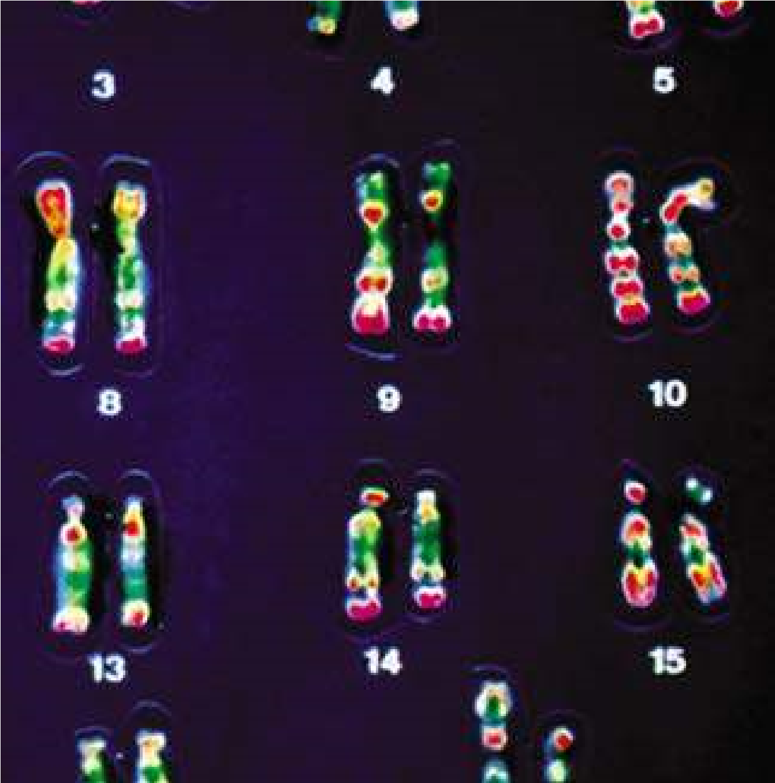

*Fig. 20.3 A human karyotype*

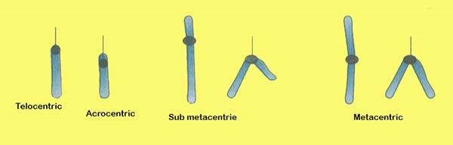

*Fig. 20.4 Shapes of chromosomes depends upon the location of centromere*

These chromosomes- acquire diferent shapes at the time of anaphase during cell division. The usual shapes are i, j and v.

**COMPOSITION OF CHROMOSOME**

Chromosomes are composed of DNA and protein. Most are about 40% DNA and 60% protein. A signiicant amount of RNA is also associated with chromosomes, because these are the sites of RNA synthesis. The DNA of a chromosome is one very long, double stranded iber that extends unbroken through the entire length of the chromosome. A typical human chromosome contains about 140 million (1.4 x 108) nucleotides in its DNA. The amount of information, one chromosome contains would ill about 280 printed books of 1000 pages each, if each nucleotide corresponds to a word and each page had about 500 words on it. Further more, if the strand of DNA from a single chromosome were laid out in a straight line, it would be about 5 centimeter long. Fitting such a strand into a small space of nucleus is nature’s marvel - and that’s only 1 of 46 chromosomes. In the cell, however, the DNA is coiled allowing it to it into a much smaller space than would otherwise be possible.

How can this long DNA ibre coil so tightly? If we gently disrupt a eukaryotic nucleus and examine the DNA with an electron microscope, we ind that it resembles a string of beads (Fig 20.5). Every 200 nucleotides, the DNA duplex is coiled around a core of eight histone proteins forming a complex known as a nucleosome. Unlike most proteins, which have an overall negative charge, histones are positively charged due to an abundance of the basic amino acids arginine and lysine. They are thus strongly attracted to the negatively charged phosphate groups of the DNA. The histone cores thus act as magnetic forms that promote and guide the coiling of the DNA. Further coiling occurs when the string of nucleosomes wraps up into higher order coils called supercoils.

Highly condensed portions of the chromatin are called **heterochromatin**. Some of these portions remain permanently condensed, so that their DNA is never expressed. The remainder of the chromosome called **euchromatin** is condensed only during cell division,

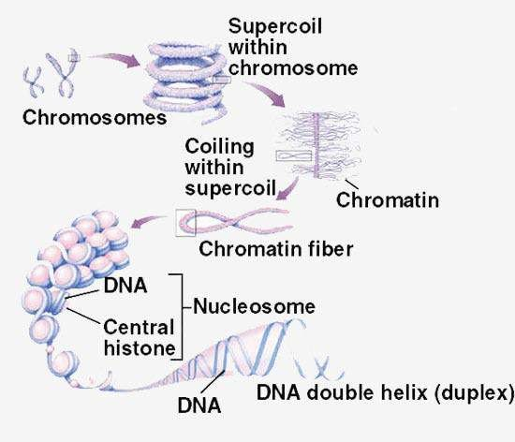

*Fig. 20.5 Levels of eukaryotic chromosomal organization*

when compact packaging facilitates the movement of the chromosomes. At all other times, euchromatin is present in an open coniguration and its genes can be 125 expressed. The way, chromatin is packaged when the cell is not dividing is not well understood beyond the level of nucleosomes and is a topic of intensive research.

### THE CHROMOSOMAL THEORY OF INHERITANCE

A central role for chromosomes in heredity was irst suggested in 1900 by the German geneticist Karl Correns, in one of the papers announcing the rediscovery of Mendel’s work. Soon after, observations that similar chromosomes paired with one another during meiosis led directly to the chromosomal theory of inheritance, irst formulated by the American Walter Sutton in 1902.

Several pieces of evidence supported Sutton’s theory. One was that reproduction involves the initial union of only two cells, egg and sperm. If Mendel’s model was correct, then these two gametes must make equal hereditary contributions. Sperm, however, contain little cytoplasm, suggesting that the hereditary material must reside within the nuclei of the gametes. Furthermore, while diploid individuals have two copies of each pair of homologous chromosomes, gametes have only one. This observation was consistent with Mendel’s model, in which diploid individuals have two copies of each heritable gene and gametes have one. Finally, chromosomes segregate during meiosis, and each pair of homologue orients on the metaphase plate independently of every other pair.

There is however one problem with this theory. If Mendelian characters are determined by genes located on the chromosomes, and if the independent assortment of Mendelian traits relects the independent assortment of chromosomes in meiosis, why does the number of characters that assort independently in a given kind of organism often greatly exceed the number of chromosome pairs the organism possesses? This has led many early researchers to have serious reservations about Sutton’s theory.

In 1910 Thomas Hunt Morgan, studying the fruit ly, Drosphila melanogaster, detected a mutant male ly, one that difered strikingly from normal lies of the same species its eyes were white instead of red.

Morgan crossed mutant male to a normal female. All F1 progeny had red eyes. He then crossed red eyed lies from F1 generation with each other. Of the 4252 F2 progeny Morgan examined, 782 (18%) had white eyes. Although the ratio of red eyes to white eyes in the F2 progeny was greater than 3:1, the results of the cross nevertheless provided clear evidence that eye colour segregates.

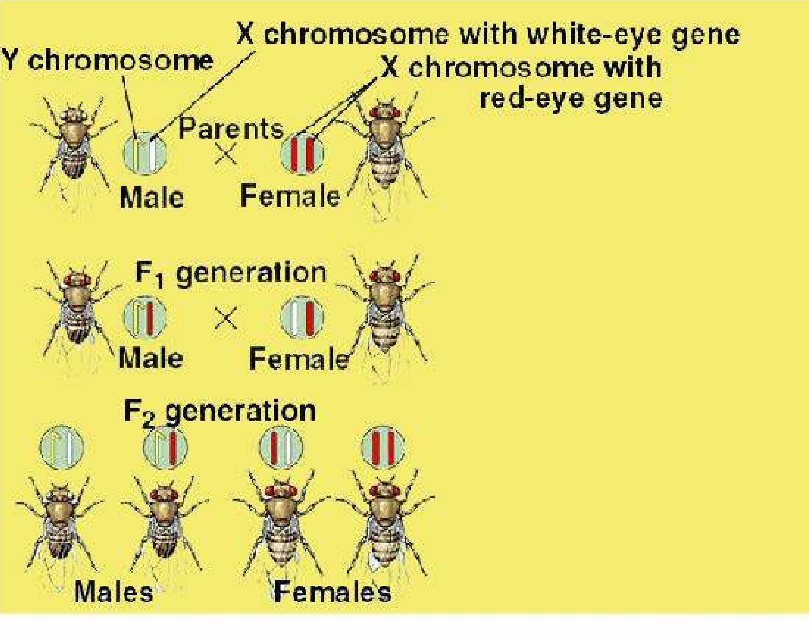

*Fig. 2Q.6 Morgan’s experiment demonstrating the chromosomal basis of Sex linkage.*

However, there was something about the outcome that was strange and totally unpredicted by Mendel’s theory - all of the white eyed F2 lies were male!

How could this result be explained? Perhaps it was impossible for a white eyed female ly to exist; such individuals might not be viable for some unknown reason. To test this idea, Morgan test crossed the female F1 progeny with the original white eyed male. He obtained both white-eyed and red-eyed males and females in a 1:1:1:1 ratio, just as Mendelian theory predicted. Hence a female could have white eyes. Why, then were there no white eyed females among the progeny of the original cross?

The solution to this puzzle involved sex. The gene causing the white eye trait in Drosophila resides only on the X chromosome. It is absent from the Y chromosome. A trait determined by a gene on the X chromosome is said to be sex linked. Knowing that the white eye trait is recessive to the red eye trait, the Morgan’s result was a natural consequence of the Mendelian assortment of chromosomes (Fig 20.6).

Morgan’s experiment was one of the most important in the history of genetics because it presented the irst clear evidence that the genes determining Mendelian traits do indeed reside on the chromosomes, as Sutton had proposed. The chromosome theory of inheritance therefore, propounds that genes are located on chromosomes. The segregation of the white-eye trait has one-to-one correspondence with the segregation of the X chromosome, in other words, Mendelian traits such as eye colour in Drosophila assort independently because chromosomes do.

### DNA AS HEREDITARY MATERIAL

The irst evidence of hereditary nature of DNA was provided by a British microbiologist Frederick Griith who made some unexpected observations while experimenting with pathogenic bacteria. When he infected mice with a virulent strain of Streptococcus pneumoniae bacteria (then known as Pneumococcus), the mice died of blood poisoning. However, when he infected similar mice with a mutant strain of S. pneumoniae that lacked the virulent strains polysaccharide coat, the mice showed no ill efects. The coat was apparently necessary for virulence.

The normal pathogenic form of this bacterium is referred to as the S form because it forms smooth colonies on a culture dish. The mutant forms, which lacks an enzyme needed to manufacture the polysaccharide coat, is called the R form because it forms rough colonies.

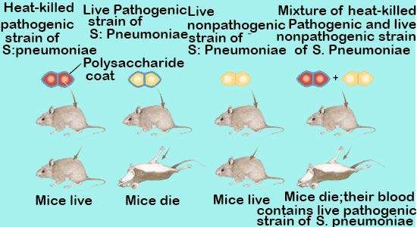

*Fig 20.7 Griith’s discovery of transformation*

To determine whether the polysaccharide coat itself had a toxic efect. Griith injected dead bacteria of the virulent S strain into the mice; the mice remained perfectly healthy. As a control, he injected mice with a mixture containing dead S bacteria of the virulent strain and live coatless R bacteria, each of which by itself did not harm the mice (Fig 20.7). Unexpectedly, the mice developed the disease symptoms and many of them died. The blood of the dead mice was found to contain high levels of live, virulent streptococcus type S bacteria, which had surface proteins characteristic of the live (previously R) strain. Somehow, the information specifying the polysaccharide coat had passed from the dead, virulent S bacteria to the live, coatless R bacteria in the mixture, permanently transforming the coatless R bacteria into the virulent S variety. Transformation is the transfer of. genetic material from one cell to another and can alter the genetic make up of the recipient cell.

The agent responsible for transforming Streptococcus went undiscovered until 1944. In a classic series of experiments, Oswald Avery along with Colin Macleod and

Maclyn McCarty characterized what they referred to as the “Transforming principle”.

They irst prepared mixture of dead S Streptococcus and live R Streptococcus that Griith had used. Then they removed as much of the protein as they could from their preparation, eventually achieving 99.98% purity. Despite removal of nearly all the protein, the transforming activity was not reduced. Moreover, the properties of transforming principle resembled those of DNA. The protein digesting enzymes or RNA digesting enzymes did not afect the principle’s activity, but the DNA digesting enzyme DNase destroyed all the transforming activity.

Additional evidence supporting Avery’s conclusion was provided in 1952 by Alfred Hershey and Martha Chase who experimented with bacteriophages T2. In some experiments they labelled viruses with radio isotope 32P, which was incorporated into the newly synthesized DNA of grooving phage. In other experiments, the viruses were grown on a medium containing 35S, an isotope of sulphur which is incorporated into the amino acids of newly synthesized protein coats.

After the labelled viruses were permitted to infect bacteria, the bacterial cells were agitated violently to remove the protein coats of the infecting viruses from the surfaces of the bacteria. This procedure removed nearly all of the 35S label from the bacteria. However the 32P label had transferred to the interior of the bacteria (Fig 20.8) and was found in viruses subsequently released from the infected bacteria. Hence, the hereditary information injected into the bacteria that speciied the new generation of viruses was DNA and not protein.

*Animation 20.2: DNA*

*Source & Credit:* [*Mr.Birnbaum’s Biology*](http://https://sites.google.com/a/dysart.org/mr-birnbaum-s-biology-class/dna-rna)

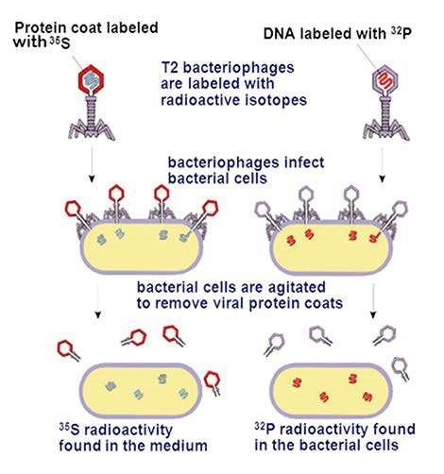

*Fig 20.8 the Hershey and chase experiment*

#### Chemical Nature of DNA

A German Chemist, Friedrich Miescher, discovered DNA in 1869, only four years after Mendel’s work was published. Miescher extracted a white substance from the nuclei of human cells and ish sperm. He called this substance “nuclein” because it seemed to be speciically associated with the nucleus.

Since nuclein was acidic, it came to be known as nucleic acid. For 50 years biologists did little research on the substance, because nothing was known of its function in cells. In 1920’s, the basic structure of nucleic acids was determined by the biochemist P.A. Levene, who found that DNA contains three main components (Fig 20.9) : (1) phosphate (P04) groups, (2) ive carbon sugars, and (3) nitrogen containing bases called purines (adenine, A, and guanine, G) and pyrimidines (thymine, T and cytosine, C, RNA contains uracil, U instead of T). Levene concluded that DNA and RNA molecules are made of repeating units called nucleotides. In a nucleotide nitrogen base is attached to carbon number 1 of a pentose sugar and phosphate group is attached to carbon number 5 of the sugar. In addition a free hydroxyl (-OH) group is attached to the 3’ carbon atom (Fig 20.10). The 5 ‘phosphate and 3’ hydroxyl groups allow DNA and RNA to form long chains of nucleotides, because these two groups can react chemically with each other. The reaction between the phosphate group of one nucleotide and the hydroxyl group of another is a dehydration synthesis, eliminating a water molecule and forming a covalent bond that links the two groups (Fig 20.11). The linkage is called a phosphodiester bond because the phosphate group is now linked to the two sugars by means of a pair of ester (P-O-C) bonds. The two unit polymer resulting from this reaction still has a free 5’ phosphate group at one end and a free 3’ hydroxyl group at the other, so that it can link to other nucleotides. In this way, many thousands of nucleotides can join together in long chains. Linear strands of DNA or RNA no matter how long, will almost always have a free 5’ phosphate group at one end and a free 3’hydroxyl group at the other.

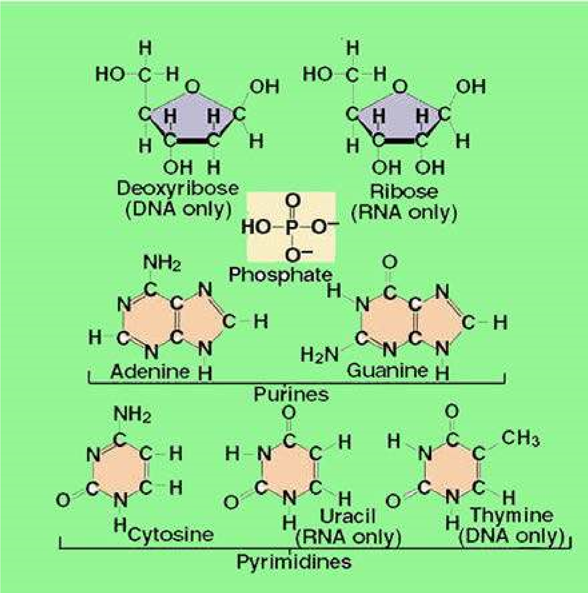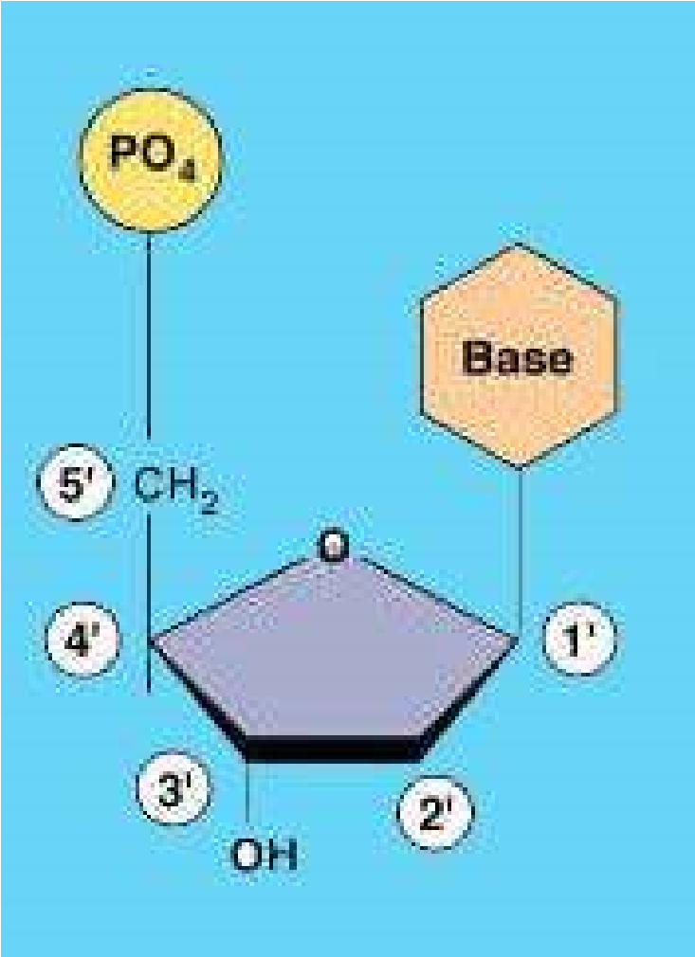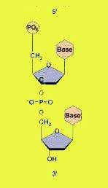

*Fig*

*20.10*

*Numbering*

*the carbon atoms in a*

*ncleoties*

*Fig 20.11 A phosphodiester Fig 20.9 Nucleotide subunits of DNA and bond.*

*RNA*

’

Erwin Chargaf later showed that the amount of adenine in DNA always equals the amount of thymine, and the amount of guanine always equals the amount of cytosine. It also implies that there is always equal proportion of purine (A+G) and pyrimidine (C+T).

The signiicance of the regularities pointed out by Chargaf became obvious when a British chemist Rosalind Franklin carried on an X-ray difraction analysis of DNA.In this analysis, a molecule is bombarded with a beam of X- rays. When individual rays encounter atoms their path is bent or difracted and the difraction pattern is recorded on the photographic ilm. When carefully analyzed this pattern gives three dimensional structure of a molecule.

Rosalind Franklin prepared this X- ray difraction pattern of DNA in the laboratory of British Biochemist Maurice Wilkins, who prepared DNA ibers. The difraction pattern suggested that the DNA molecule had a shape of a helix with a diameter of 2 nm and a complete helical turn every 3.4 nm (Fig 20.12).

#### Double Helical Structure of DNA (Watson and Crick’s Model)

Learning informally of Franklin’s results, before they were published in 1953, James Watson and Francis Crick, two young researchers in University’ of Cambridge, quickly worked out a likely structure of the DNA molecule (Fig 20.12) which we now know was substantially correct. They’ proposed that molecule is a simple double helix, with the basis of two strands pointed inward toward each other. forming base-pairs. In their model, base pairs always consist of purines, which are large, pointing toward pyrimidines which are small, keeping the diameter of the molecule a constant 2 nm. Because hydrogen bonds exist between the bases in a base pair, the double helix is stabilized as a duplex DNA molecule composed of two antiparallel strands, one chain running 3’ to 5’ and the other 5’ to 3’. The base pairs are planar (lat) and stack 0.34nm apart as a result of hyperphobic interactions contributing to the overall stability of the molecule (Fig. 20.3). In the double helix, adenine forms two hydrogen bonds with thymine, while guanine forms three hydrogen bonds with cytosine. Adenine will not form proper hydrogen bonds with cytosine.and guanine will not form hydrogen bonds with thymine. Consequently adenine and thymine will always occur in the same proportion in any DNA molecule, as well guanine and cytosine, because of this base pairing.

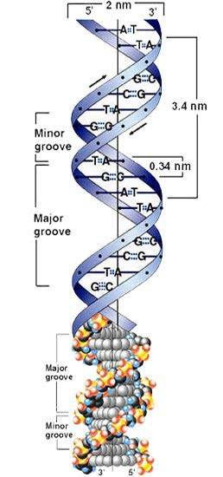

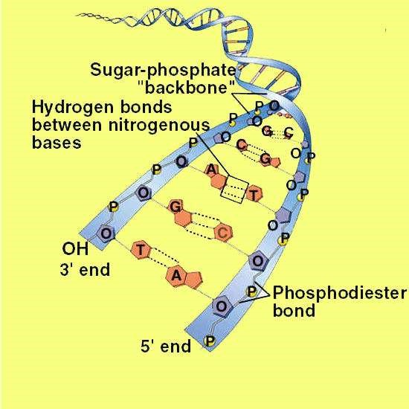

*Fig 20.13 DNA is a double helix*

##### DNA Replication

The Watson - Crick model immediately suggested that the basis for copying the genetic information is complementarity. If one were to unzip the molecule, one would need only to assemble the appropriate complementary nucleotides on the exposed single strands to form two daughter complexes with the same sequences. This form of DNA replication is called **semi-conservative**, because while the sequence of the original duplex is conserved after one round of replication, the duplex itself is not. Instead, each strand of the duplex becomes part of another duplex. In semi-conservative replication, the two133 strands of the duplex separate out each acting as a model or mold, along which new nucleotides are arranged thus giving rise to two new duplexes. In this process by separation of two strands, primary structure has been conserved, whereas the secondary structure has been disrupted.

The other hypotheses of DNA replication were also proposed. The conservative model stated that the parental double helix would remain intact and generate DNA copies consisting of entirely new molecules. The dispersive model predicted that parental DNA would become completely dispersed and that each strand of all the daughter molecules would be a mixture of old and new DNA.

*Animation 20.3: DNA Replication*

*Source & Credit:* [*weloveteaching*](http://http://weloveteaching.com/0bio105/lectures/chemistry/DNAreplication.html)

###### The Meselson - Stahl Experiment

The three hypothesis of DNA replication were evaluated by Mathew Meselson and Franklin Stahl of the California Institute of Technology in 1958. They grew bacteria in a medium containing heavy isotope of nitrogen, 15N, which became incorporated into the bases of the bacterial DNA. After several generations, the DNA of these bacteria was denser than that of bacteria grown in a medium containing the lighter isotope of nitrogen, N14. Meselson and Stahl then transferred the bacteria from the N15 medium to the N14 medium and collected the DNA at various intervals.

They dissolved the DNA in cesium chloride and then spun it at a very high speed in an ultra-centrifuge. DNA strands of diferent densities got separated. The enormous centrifugal forces generated by the ultracentrifuge caused the cesium ions to migrate toward the bottom of the centrifuge tube, creating a gradient of CsCl, and thus of density. Each DNA loats or sinks in the gradient until it reaches the position where its density exactly matches the density of cesium there. Because N15 strands are denser than N14 strands, they migrate farther down the tubes to a denser region of the cesium chloride gradient.

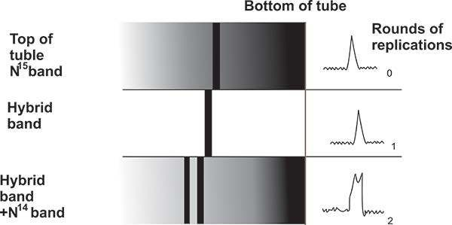

*Fig. 20.14 The key result of the Meselson and Stahl experiment. The bands on the left side of*

*the igure sTiow N 1’ DNA which is heavier and is present towards the bottom of the tube. The middle band is a hybrid DNA band of N1’ and NM and hence lies above the Nlr band. This is*

*after irst round of replication. In the second round of replication, two bands are \isible one at the lex el of hybrid band and the other lighter band which is N14 band.*

The DNA collected immediately after the transfer, was all dense. However, after the bacteria completed their irst round of DNA replication in the N 14 medium, the density of their DNA had decreased to a value intermediate between N14- DNA and N15 - DNA. After the second round of replication, two density classes of DNA were observed one intermediate and one equal to that of N14 - DNA (Fig 20.14).

Meselson and Stahl interpreted their results as follows: after the irst round of replication, each daughter DNA duplex was a hybrid possessing one of the heavy strands of parent molecule and one light strand. When this hybrid duplex replicated, it contributed one heavy strand to form another hybrid duplex and one light strand to form a light duplex (Fig 20.15). Thus, this experiment clearly conirmed the prediction of the Watson-Crick model that DNA replicates in a semi-conservative manner.

*Animation 20.3: Meselson-Sathl Experiment Source & Credit:* [*weloveteaching*](http://http://weloveteaching.com/0bio105/lectures/chemistry/DNAreplication.html)

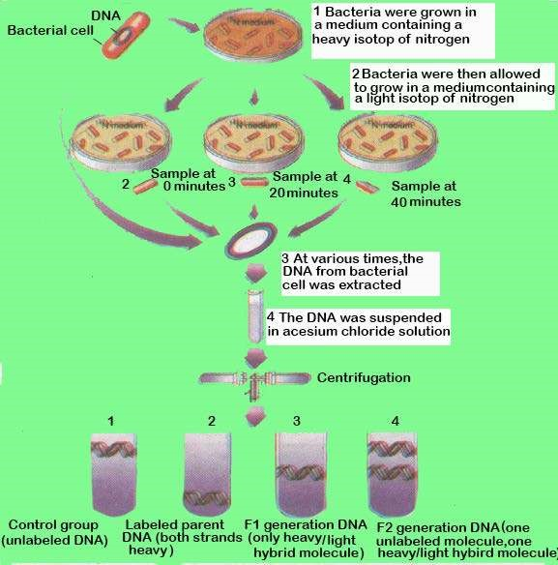

*Fig 20.15 The Meselson and stahl experiment : evidence demonstrting sei-conservative replication*

###### The Replication Process

The DNA replication begins at one or more sites on the DNA molecule, where there is a speciic sequence of nucleotides (Fig 20.16), The DNA polymerase III and other enzymes begin a complex process that catalyzes the addition of nucleotides to the growing complementary strands of DNA (Fig 20.17).

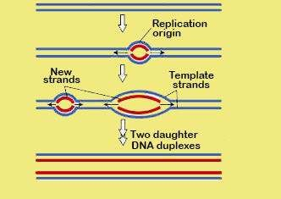

*FIg 20.16 Origins of replication*

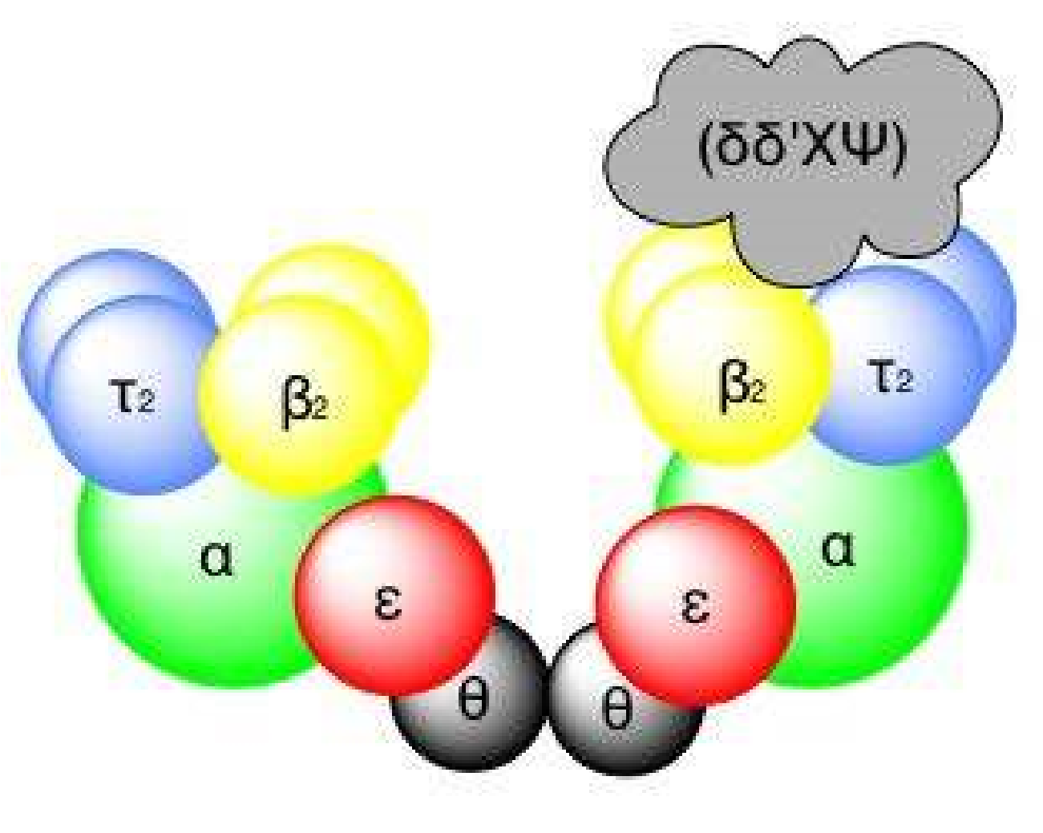

*Fig 20.18 Molecular structure of DNA polymerse III comle*

There are three DNA polymerases namely I, II and III in bacteria. DNA polymerase I is a relatively small enzyme that plays a supporting role in DNA replication. The true E.coli replicating enzymes is DNA polymerase III which is 10 times larger and far more complex in structure (Fig 20.18). The enzyme is a dimer and catalyzes replication of one DNA strand. Polymerase III progressively threads the DNA through the enzyme complex, moving at a rapid rate, some 1000 nucleotides / second. One of the features of the DNA polymerase III is that it can add nucleotides only to a chain of nucleotides that is already paired with the parent strands. Hence DNA polymerase cannot initiate synthesis on its own. Instead another enzyme, primase, constructs an RNA primer, a sequence of about 10 RNA nucleotides complementary to the parent DNA template. DNA polymerase IIIrecognizes the primer and adds DNA” nucleotides to it to construct the DNA strands. The RNA nucleotides in the primers are then replaced by DNA nucleotides.

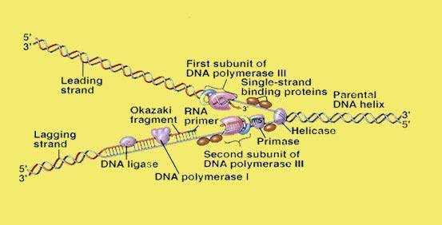

*Fig 20.19 A DNA replication fork*

Another feature of DNA polymerase III is that it can add nucleotides only to the 3’ end of a DNA strand. This means that replication always proceeds 5’ —» 3’ direction on a growing DNA strand. Because the two parent strands of a DNA molecules are antiparallel, the new strands are oriented in opposite directions (Fig 20.19). Therefore, the new strands must be elongated by diferent mechanisms. Leading strand, which elongates toward the replication fork, is built up simply by adding nucleotides continuously to its growing 3’ end. In contrast the lagging strand which elongates away from the replication fork, is synthesized discontinuously as a series of short segments that are later connected. These segments, called Okazaki fragments are about 100 - 200 nucleotides long in eukaryotes and 1000 - 2000 nucleotides long in prokaryotes. Each Okazaki fragment is synthesized by DNA polymerase III in 5’ -> 3’ direction, beginning at the replication fork and moving away from it. When the polymerase reaches the 5’ end of the lagging strand, another enzyme, DNA ligase, attaches the fragment to the lagging strand. The DNA is further unwound, new RNA primers are constructed, and DNA polymerase III then jumps ahead 1000 - 2000 nucleotides (toward the replication fork) to begin constructing another Okazaki fragment.

**WHAT IS A GENE?**

Archibald Garrod and William Bateson concluded in 1902 that certain diseases among their patients were more prevalent in particular families. By examining several generations of these families, Garrod found that some of the diseases behaved as if they were the product of simple recessive alleles. He concluded that these disorders were Mendelian traits and that they had resulted from changes in the hereditary information in an ancestor of the afected families.

Garrod investigated several of these disorders in detail. In alkaptonuria the patients produced urine that contained homogentisic acid. This substance oxidized rapidly when exposed to air, turning the urine black. In normal individuals, homogentisic acid is broken down into simpler substances. With considerable insight Garrod concluded that patients sufering from alkaptonuria lacked the enzyme necessary to catalyze this breakdown. He speculated that many other inherited diseases might also relect enzyme deiciencies.

From Garrod’s inding, it could be inferred that the information encoded within the DNA of chromosomes acts to specify particular enzymes. This point was not actually established, however, untill 1941, when a series of experiments by Stanford University geneticists George Beadle and Edward Tatum provided deinitive evidence on this point. Beadle and Tatum deliberately set out to create Mendelian mutations in chromosomes and then studied the efect of these mutations on the organisms (Fig 20.20).

Beadle and Tatum exposed Neurospora spores to X-rays, expecting that DNA in some of these spores would experience damage in the regions encoding the ability to make compounds needed for normal growth (Fig 20.20). DNA changes of this kind are called mutations and the organisms that have undergone such changes are called mutants. Initially, they allowed the progeny of the irradiated spores to grow on a deined medium containing all of the nutrients necessary for growth, so that any growth deicient mutants resulting from the irradiation would be kept alive.

To determine whether any of the progeny of the irradiated spores had mutations causing metabolic deiciencies, Beadle and Tatum placed subcultures of individual fungal cells on a “minimal” medium that contained only sugar, ammonia, salts, a few vitamins and water. Cells that had lost the ability to make other compounds necessary for growth would not survive on such a medium. Using this approach, Beadle and Tatum succeeded in identifying and isolating many growth deicient mutants.

Next the researchers added various chemicals to the minimal medium in an attempt to ind one that would enable a given mutant strain to grow. This procedure allowed them to pinpoint the nature of the biochemical deiciency that strain had. The addition of arginine, for example, permitted several mutant strains, dubbed arg mutants, to grow. When their chromosomal positions were located, the arg mutations were found to cluster in three areas.

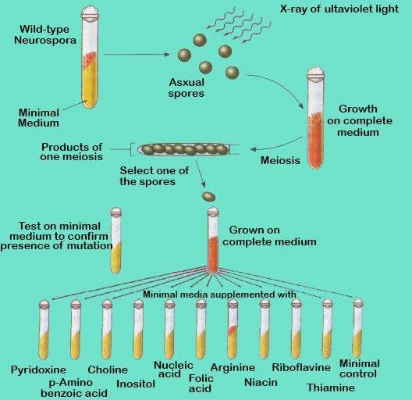

*Fig 20.20 Beadle and Tatum’s procedure for isolating nutritional mutats in Neurospora*

###### One - gene / one - polypeptide Hypothesis

For each enzyme in the arginine biosynthetic pathway, Beadle and Tatum were able to isolate a mutant strain with a defective form of that enzyme, and the mutation was always located at one of a few speciic chromosomal sites. Most importantly, they found there was a diferent site for each enzyme. Thus, each of the mutant they examined had a defect in a single enzyme, caused by a mutation at a single site on one chromosome. Beadle and Tatum concluded that genes produce their efects by specifying the structure of enzymes and that each gene encodes the structure of one enzyme (Fig 20-21). They called this relationship one - gene / one - enzyme hypothesis. Because many enzymes contain multiple protein or polypeptide subunits, each encoded by a separate gene, the hypothesis is today more commonly referred to as “one gene / one- polypeptide”.

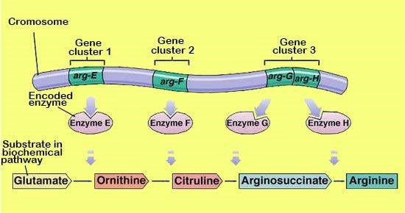

*Fig. 20.21 Evidence for the “one-gone/one-polypeptide” hypothesis.*

Enzymes are responsible for catalyzing the synthesis of all the parts of an organism. They are also responsible for the assembly of nucleic acids, proteins, carbohydrates and lipids. Therefore, by encoding the structure of enzymes and other proteins, DNA speciies the structure of the organism itself. **How DNA encodes protein structure?**

In 1953, an English biochemist Frederick Sanger, described the complete sequence of amino acids of insulin. Sanger’s achievement was signiicant, as it was demonstrated for the irst time that proteins consisted of deinable sequences of amino acids. Soon it was revealed that all enzymes and other proteins are strings of amino acids arranged in a certain deinite order.

Following Sanger’s pioneering work, Vernon Ingram in 1956 discovered the molecular basis of sickle cell anemia, a protein defect inherited as a Mendelian disorder. By analyzing the structure of normal and sickle cell haemoglobin, Ingram, working at Cambridge University, showed that sickle cell anemia is caused by a change from glutamic acid to valine at a single position in the protein (Fig 20.22). The alleles of the gene encoding hemoglobin difered only in their speciication of this one amino acid in the hemoglobin amino acid chain.

These experiments and other related ones have inally brought us to a clear understanding of the unit of heredity. The characteristics of sickle cell anemia and most other hereditary traits are deined by changes in protein structure brought about by an alteration in the sequence of amino acids that make up the protein. This sequence in turn is dictated by the order of nucleotides in a particular region of chromosome. For example, the critical change leading to sickle cell disease is a mutation that replaces a single thymine with an adenine at the position that codes for glutamic acid converting the position to valine. The sequence of nucleotides that determines the amino acid sequence of a protein is called a gene.

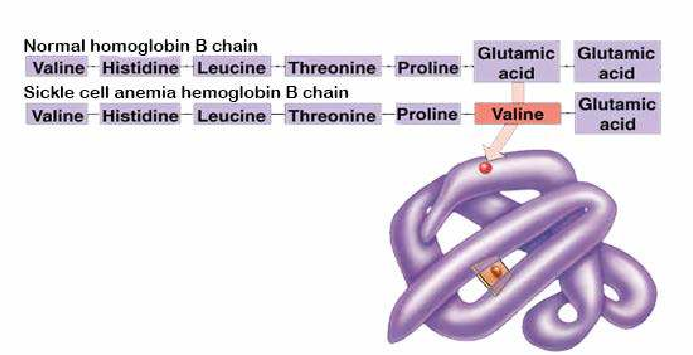

*Fig 20.22 The necular basic of a hereditary disease , sickle cell anemia*

### CELLS USE RNA TO MAKE PROTEIN

All organisms use the same basic mechanism of reading and expressing genes, which is often referred to as central dogma. The genetic information resides in DNA, which is also the main fountain head. The genetic information lows down into RNA, which is then converted into protein (Fig 20.23).

The irst step of central dogma is the transfer of information from DNA to RNA, which occurs when an mRNA copy of the gene is produced. The process is called transcription. Transcription is initiated when the enzyme RNA polymerase binds to a particular binding’ site called a prom oter located upstream of the gene. The enzyme then moves along the strand into the gene and mRNA is synthesized. At stop signal on the other end of gene, the enzyme disengages itself from the DNA and releases the newly assembled RNA chains. This chain is a complementary transcript of the gene from which it was copied.

The second step of the central dogma is the transfer of information from RNA to proteins, which occurs when the information contained in the mRNA is used to direct the synthesis of polypeptides by ribosomes. This process is called translation, because the nucleotide sequence of the mRNA is translated into an amino acid sequence in the polypeptide.

The two steps of central dogma taken together are also means of gene expression.

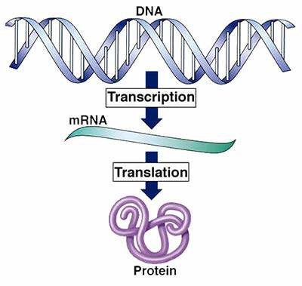

*Fig. 20.23 The central dogma of gene expression.*

#### Three types of RNA

The class of RNA found in ribosome is called ribosomal RNA (rRNA). During translation, rRNA provides the site where polypeptides are assembled. In addition to rRNA, there are two other major classes of RNA in the cells : transfer RNA (tRNA) and messenger RNA (mRNA). Transfer RNA molecules transport the amino acids to the ribosomes for use in building the polypeptides and also position each amino acid at the correct place on the elongating polypeptide chain (Fig 20.24). Human cells contain about 45 diferent kinds of tRNA molecules. Messenger RNA are long strands of RNA that are transcribed from DNA and that travel to the ribosomes to direct precisely which amino acids are assembled into polypeptides.

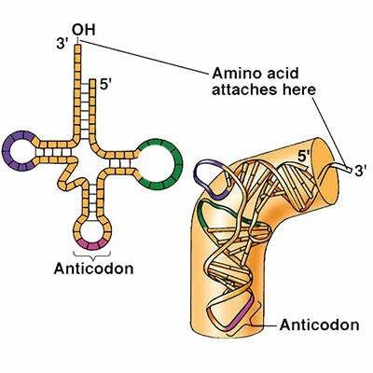

*Fig. 20.24 The structure of tRNA*

1. *two-dimensional schematic*
2. *three dimensional structure.*

##### Transcription

This is the process in which an RNA copy of the DNA sequence encoding the gene is produced with the help of an enzyme, RNA polymerase. Only one of the two strands of DNA are transcribed. This strand is called template strand or the antisense strand. Thq opposite strand is called coding strand or the sense strand. The RNA polymerase enzymes synthesize RNA from 5’ —» 3’ direction. There is only one type of RN A polymerase in prokaryote which is responsible for the synthesis of all the three types of RNAs viz. rRNA, mRNA and tRNA. On the other hand there are three types of RNA polymerases in eukaryotes namely RNA polymerase I, which synthsize rRNA, RNA polymerase II, which synthesizes mRNA and RNA polymerase III which synthesizes tRNA.

Transcription starts at the RNA polymerase binding site called promoter on the DNA template strand. In prokaryotes within promoter there are two binding sites TTGACA also called -35 sequence and TAT A AT sequence also called -10 sequence, which have ainity for the RNA polymerase. In eukaryotes these sites are at -75 and -25 sites, respectively

The binding of RNA polymerase to the promoter is the irst step in gene transcription. One of the subunits of RNA polymerase sigma factor, is responsible for correct initiation of transcription process. Once the transcription has started the sigma factor is released and the remaining part of the enzyme (core enzymes) moves over template; strand and completes the transcription of the gene. The DNA strands open up at the place where enzyme is attached to the templete strand forming transcription bubble. The transcription bubble moves down the DNA, leaving the growing strand protruding from the bubble (Fig 20.25). The stop sequences at the end of the gene terminate the synthesis of mRNA. The simplest stop signal is a series of GC base pairs followed by a series of AT base pairs. The RNA formed in this region forms a GC hairpin (Fig 20.27) followed by four or more U ribonucleotides. The hairpin causes RNA polymerase to stop synthesis.

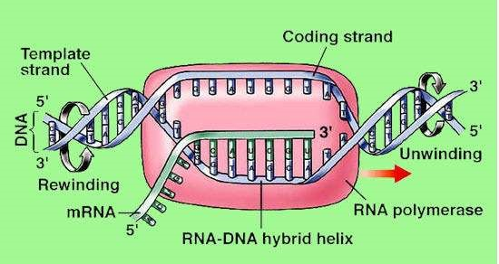

*Fig. 20.25 Model of a transcription bubble.*

In bacteria the newly synthesized mRNA is directly released into the pytoplasm, when it is converted into polypeptide chain. In eukaryotes however, it has to travel long distance from inside the nucleus to ribosomes outside in the cytoplasm. The eukaryotic mRNA is therefore modiied in several ways to aid this journey. A cap and a tail is added so that the molecule may remain stable during long journey to ribosome. The cap is in the form of 7 methyl GTP, which is linked 5’ to 5’ with the irst nucleotide, whereas tail is in the form of poly A tail linked to 3’ end of the RNA. These caps and tails save the mRNA from variety of nucleases and phosphatases. **GENETIC CODE**

Genetic code is a combination of 3 nucleotides, which specify a particular amino acid. There are three nucleotides in .a codon, because a two nucleotide codon would not yield enough combinations to code for the 20 diferent amino acids that commonly occur in proteins. With four DNA nucleotides (G,C, T and A ) only 42 or 16, diferent pairs of nucleotides could be formed. However, these same nucleotides can be arranged in 43 or 64 diferent combinations of three, more than enough to code for the 20 amino acids. The genetic code is a triplet code and the reading occurs continuously without punctuation between the three nucleotide units.

After Crick’s initial experiments, Marshall Nirenberg, Philip Leader and Har Gobind Khorana tested all the 64 codons by making artiicial mRNAs and triplet codons and using them to synthesize a protein or aminoacyl-tRNA complexes in cell free systems. ‘ The full genetic code was determinal during m id 60s (Table 20.1). Out of 64 codons, three codons UAA, UAG and UGA do not code for any amino acid and hence are known as nonsense codons. These codons are usually present at the end of the gene and hence are also called stop codons. Every gene starts with initiation codon AUG, which encodes the amino acid methionine.

|  |  |  |  |  |  |  |  |  |  |
| --- | --- | --- | --- | --- | --- | --- | --- | --- | --- |
| Table 20.1 The Genetic Code | | | | | | | | | |
| *Second Letter*  *First letter U C A G Third letter* | | | | | | | | | |
| *U* | *UUU*  *UUC* | phenylalanine | *UCU*  *UCC* | Serine | *UAU*  *UAC* | Tryosine | UGU UGC | Cysteine | *U*  *C* |
|  | UUA  UUG | Leucine | *UCA UCG* |  | *UAA UAG* | Stop  Stop | *UGA UGG* | Stop  Tryptophan | *A G* |
| C | *CUU*  *CUC* | Leucine | *CCU*  *CCC* | Proline | *CAU*  *CAC* | Histidine | *CGU*  *CGC* | Arginine | *U*  *C* |
|  | *CUA CUC* |  | *CCA CCG* |  | *CAA CAG* | Glutamine | *CGA CGG* |  | *A G* |
| *A* | *AUU*  *AUC* | Isoleucine | *ACU*  *ACC* | Treonine | *AAU*  *AAC* | Asparagine | *AGU*  *AGC* | Serine | *U*  *C* |
|  | *AUA AUG* | Methionine; Start | *ACA ACG* |  | *AAA AAG* | Lysine | *AGA AGG* | Arginie | *A G* |
| *G* | *GUU*  *GUC* | Valine | *GCU*  *GCC* | Alanine | *GAU*  *GAC* | Aspartate | *GGU*  *GGC* | Glycine | *U*  *C* |
|  | *GUA GUG* |  | *GCA GCG* |  | *GAA GAG* | Glutamate | *GGA GGG* |  | *A G* |

The genetic code is universal. It is the same in almost all the organisms. For example AGA speciies arginine in bacteria, in humans and all other organisms whose genetic code has been studied. Because of the universality of codon, the genes can be transferred from one organism to another and be successfully transcribed and translated in their new host.

The study of genetic code of mitochondrial DNA however, showed that genetic code is not that universal. For example UGA codon is normally a stop codon but, in mitochondria it reads as tryptophan. Likewise AUA was read as methionine instead of isoleucine and AG A and AGG for termination of protein synthesis is instead of arginine. Thus it appearsthatgenetic code is not quite universal.

### TRANSLATION

In prokaryotes, translation begins when the initial portion of an mRNA molecule binds to rRNA molecule in a ribosome. The mRNA lies on the ribosome in such a way that only one of its codons is exposed at the polypeptide site at any time.

A tRNA molecule possessing the complementary three nucleotide sequence or anticodon, binds to the exposed codon on the mRNA. As the ribosome moves along the messenger RNA, successive codons on the mRNA are exposed and the series of tRNA m olecules bind one after another to the exposed codons. Each of these tRNA m olecules carries an attached amino acid, w hich is added to the end of the grow ing polypeptide chain.

Particular tRNA molecules become attached to speciic amino acids through the action of activating enzymes called aminoacyl-tRNA synthetase, one of which exists for each of the 20 common amino acids (Fig 20.26).

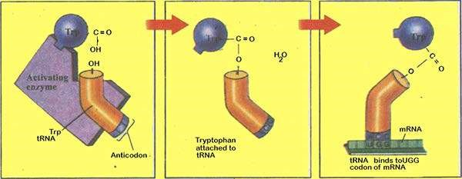

*Fig. 20.26 Activating enzymes “read” the genetic code.*

In prokaryotes, polypeptide synthesis begins with the formation of initiation complex (Fig. 20.27). First a tRNA molecule carrying a chemically modiied methionine (called N-formyl methionine) binds to the small ribosomal subunit. Proteins called initiation factor position the tRNA on the ribosomal surface at the P site (peptidyl site) where peptide bonds will form. Nearby two other sites will form. A site (for aminoacyl site), where successive amino acid bearing tRNAs will bind and the E site (for exit site) where empty tRNAs will exit the ribosome (Fig 20.27). This initiation complex, guided by another initiation factor, binds to AUG on the mRNA.

After the initiation complex has formed, the large ribosome subunit binds tRNA molecule with the appropriate anticodon appears, proteins called elongation factors assist in binding it to the exposed mRNA codon at the A site. The two amino acids which now he adjacent to each other undergo a chemical reaction, catalyzed by the large ribosomal subunit, which releases the initial methionine from its tRNA and attaches it instead by a peptide bond to the second amino acid (Fig. 20.28).

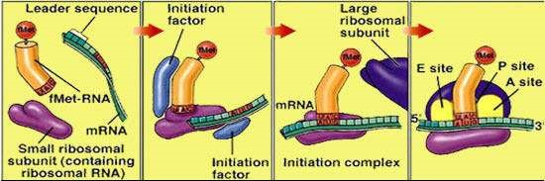

*Fig. 20.27 Formation of the initiation complex.*

The ribosome now moves (translocates) three more nucleotides along the mRNA molecule in the 5’ —> 3’ direction, guided by other elongation factors. This movement translocates the initial tRNA to the E site and ejects it from the ribosome, repositions the growing polypeptide chain (at this point containing two amino acids) to the P site, and exposes the next codon on the mRNA at the A site (Fig 20.28). When a tRNA molecule recognizing that codon appears, it binds to the codon at the A site, placing its amino acid adjacent to the growing chain. The chain then transfers to the new amino acid, and the entire process is repeated.

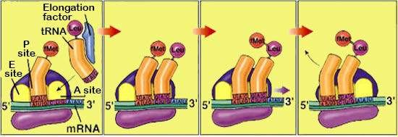

*Fig. 20.28 The translocation process.*

Elongation continues in this fashion until a chain-terminating non sense codon is exposed (for example UAA in Fig 20.29). Nonsense codons do not bind to tRNA, but they are recognized by release factors, proteins that release the newly made polypeptide from the ribosomes.

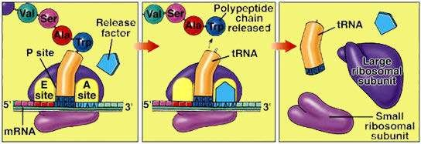

*Fig. 20.29 Termination of protein synthesis*

### MUTATIONS

The cells of eukaryotes contain an enormous amount of DNA. If the DNA in all of the cells of an adult human were lined up end to end, it would stretch nearly 100 billion kilometers - 60 times the distance from Earth to Jupiter.

Changes in the DNA occur either due to mistake in replication or damage to the genetic message causing mutations. The mutations in somatic cells do not pass on to ofspring and so have little evolutionary consequence than germ line changes. The mutation in germ line cell is passed to subsequent generations thus providing the raw material from which natural selection produces evolutionary change.

Mutations can broadly be classiied as (i) chromosomal aberration and (ii) point mutation. Chromosomal aberrations are mega changes which involve presence of an extra chromosome or loss of a chromosome from the diploid number of chromosomes, or changes like deletions, insertions, inversions etc in the parts of the chromosome, Such chromosomal aberrations lead to syndromes like Down’s syndrome, Klinefelter’s syndrome etc.

Point mutations are mutational changes which afect the message itself, producing alterations in the sequence of DNA nucleotide (Table 20.2). If alterations involve only one or a few base pairs in the coding sequence they are called point mutations. While some point mutations occur due to spontaneous pairing errors that occur during DNA replication, others result from damage to the DNA caused by mutagens, usually radiations or chemicals. The latter class of mutations is of particular practical importance because modem industrial societies often release many chemical mutagens into the environment. Sickle cell anemia and phenylketonuria are well known examples of point mutation, both of which have been discussed in previous page. In sickle ceil anemia a point mutation leads to the change of amino acid glutamic acid into valine at position 6 from N terminal end in hemoglobin P chain. This consequently alters the tertiary structure of the hemoglobin molecule, reducing its ability to carry oxygen.

In phenylketonuria, phenylalanine is not degraded because of defective enzyme phenylalanine hydroxylase. Phenylalanine consequently accumulates in the cells leading to mental retardation, as the brain fails to develop in infancy. This disorder is because of the point mutation.

|  |  |  |
| --- | --- | --- |
|  | **EXERCISE** |  |
| **Q.1 Fill in the blanks.** | | |

1. Particular tRNA molecules become attached to speciic amino acids through the action of activating enzymes called________________.
2. _____ _____is the transfer of genetic material from one cell to another and can alter the genetic make up of the recipient cell.
3. In a bacteria, a subunit of RNA polymerase called____________ recognizes-10 sequence in the promoter and binds RNA polymerase there.
4. A typical human chromosome contain about nucleotides in its DNA.
5. Miescher extracted a white substance from the nuclei of human cells and ish sperm and called this substance_________ .

**Q.2 Write whether the statement is true or false and write the correct statement if it is false.**

1. The strand of DNA that is not transcribed is called the coding strand.
2. TA TAAT sequence called - 35 sequence is part of promoter, where transcription actually starts.
3. Rosalind Franklin carried out an x-ray difraction analysis of DNA.
4. The base pairs in DNA helix are planar and stack 34 nm apart as a result of hydrophobic interactions.

**Q.4 Short Questions**

1. What are the three major classes of RNA?
2. What is the function of RNA polymerase in transcription?
3. How did Crick and his colleagues determine how many nucleotides are used to specify each amino acid?
4. What is anticodon?

**Q.5 Extensive Questions**

1. How did Hershey and Chase determine which components of bacterial viruses contain the hereditary information?
2. ‘ What is the three dimensional shape of DNA? How does three dimensional shape of DNA it with Chargaf s observations on the proportions of purines and pyrimidines in DNA?
3. How did Meselson and Stahl show that DNA replication is semi conservative?
4. What is the basis for the requirement that the leading and lagging strands be replicated by diferent mechanisms?
5. What hypothesis did Beadle and Tatum test in their experiments on Neurospora ?

CHAPTER 21 Cell Cycle

*Animation 21 : Cell cycle*

[*Source & Credit: Wikispaces*](http://anatomyeshs.wikispaces.com/Ch.16+Respiratory+System)

### INTRODUCTION

The cell undergoes a sequence of changes, which involves period of growth, replication of DNA, followed by cell division. This sequence of changes is called cell cycle.

It comprises two phases viz., interphase which is the period of non-apparent division and the period of division also known as mitotic phase. Each phase is further subdivided into diferent sub-phases.

### INTERPHASE

The period of life cycle of cell (cell cycle) between two consecutive divisions is termed as the interphase or misleadingly called resting phase. It is the period of great biochemical activity and can further be divided into G1-phase, S-phase and G2-phase. G1 (Gap 1) is the period of extensive metabolic activity, in which cell normally grows in size, speciic enzymes, are synthesized and DNA base units are accumulated for the DNA synthesis. Post-mitotic cell can exit the cell cycle during G1 entering a phase called G0, and remain for days, weeks, or in some cases (e.g., nerve cells and cells of the eye lens) even the life time of the organism without proliferating further. Following the G1 is the S-phase (synthesis phase) during which the DNA is synthesized and (chromosome are replicated) which initiates G2 phase (pre-mitotic phase), thus preparing the cell for division e.g., energy storage for chromosome movements, mitosis speciic proteins, RNA and microtubule subunits (for spindle ibers) synthesize. Cells then proceed to next phase which is the period of division). At each stage, there are speciic check points, which determine the fate of new phase according to cell’s internal make up. Length of each phase is variable. In the case of human cell, average cell cycle is about 24 hours, mitosis takes 30 minutes, G1 9 hours, the S-phase 10 hours, and G2 4.5 hours whereas full cycle in yeast cells is only 90 minutes.

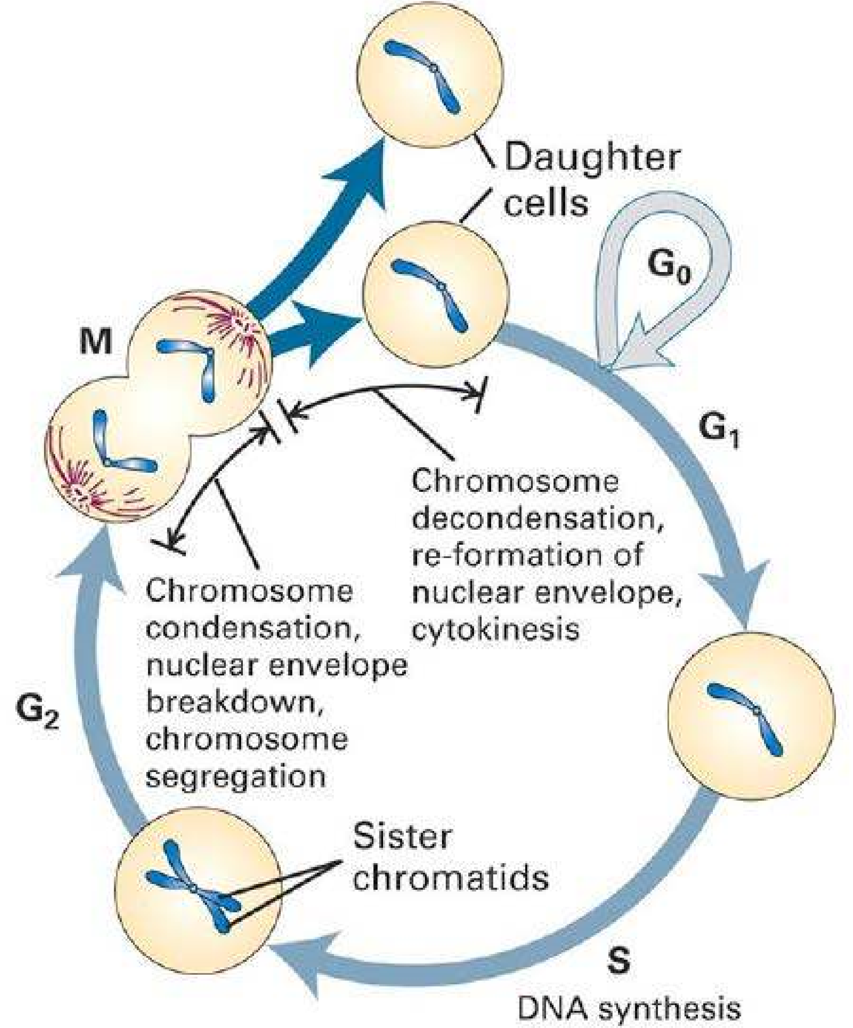

*Fig. 21.1 The fate of a single parental chromosome throughout the eukaryotic cell cycle.*

### MITOSIS

It is the type of cell division, which ensures the same number of chromosomes in the daughter cells as that in the parent cells. In spite of slight diferences, major steps of mitosis are similar in plants as well as in animals. However, to avoid the confusion our statement will base on the animal cell. It can take place in haploid as well as in diploid cells in nearly all parts of the body if and when required.

Mitosis is a continuous process, but conventionally it may be divided into two phases, i.e., karyokinesis, which involves the division of nucleus and cytokinesis that refers to the division of the whole cell (Fig.21.2).

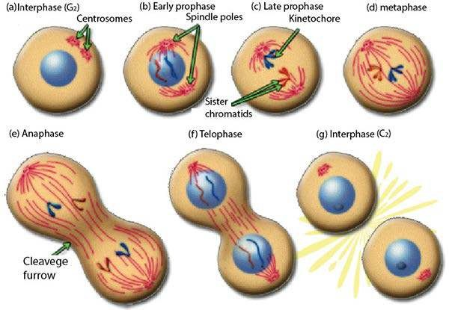

*Fig 21.2 The stages of mitosis and cytokinesis in an animal cell.*

#### Karyokinesis

At the beginning of the process in an animal cell, the partition of the centriole takes place, which have been duplicated during interphase but present in the same centrosome. Early in the mitosis the two pair of centrioles separate and migrate to opposite sides of the nucleus, establishing the bipolarity of the dividing cells.

Three sets of microtubules (ibers) originate from each pair of centrioles. One set the astral microtubules, radiate outward and form aster, other two sets of microtubules compose the spindle. The kinetochore microtubules attach to chromosomes at kinetochores and polar microtubules do not interact the chromosomes but instead interdigitate with polar microtubules from the opposite pole. These microtubules are composed of a protein tubulin and traces of RNA.

This specialized microtubule structure including aster and spindle is called mitotic apparatus. This is larger than the nucleus, and is designed to attach and capture chromosomes, aligning them and inally separating them so that equal distribution of chromosomes is ensured.

Karyokinesis can further be divided into prophase, metaphase, anaphase and telophase for thorough understanding, though it is a continuous process.

#### Prophase

During interphase (non-dividing phase) of the cell cycle the chromosomes are not visible even with electron microscope, but using histologic stains for DNA, a network of very ine threads can be visualized. This network is called as chromatin.

The chromatin material gets condensed by folding and the chromosomes appear as thin threads (0.25mm - 50mm in length) at the beginning of prophase.

Chromosomes become more and more thick ultimately each chromosome is visible having two sister chromatids, attached at centromere. Towards the end of prophase, nuclear envelope disappears and nuclear material is released in the cytoplasm, nucleoli disappear. Mitotic apparatus is organized (as described above). Cytoplasm becomes more viscous. **Metaphase**

Each metaphase chromosome is a duplicated structure which consists of two sister chromatids, attached at a point called centromere or primary constriction. The centromere has special area, the kinetochore, with speciic base arrangement and special proteins where kinetochore ibers of mitotic apparatus attach.

The kinetochore ibers of spindle attach to the kinetochore region (specialized area in centromere) of chromosome, and align them at the equator of the spindle forming equatorial plate or metaphase plate. Each kinetochore gets two ibers one from each pole. **Anaphase**

It is the most critical phase of the mitosis, which ensures equal distribution of chromatids in the daughter cells. The kinetochore ibers of spindle contract towards their respective poles, at the same time polar microtubules elongates exert force and sister chromatids are separated from centromere. As a result, half sister chromatids travel towards each pole.

##### Telophase

Reaching of the chromosomes at opposite poles terminates anaphase and start telophase. The chromosomes decondense due to unfolding, ultimately disappear as chromatin. Mitotic apparatus disorganizes nuclear membrane and nucleoli reorganize, resulting two nuclei at two poles of the cell.

##### Cytokinesis

During late telophase the astral microtubules send signals to the equatorial region of the cell, where actin and myosin are activated which form contractile ring, followed by cleavage furrow, which deepens towards the center of the cell, dividing the parent cell into two daughter cells.

Mitotic events in plant cells are generally similar to the events observed in animal cells but there are some major diferences. Most higher plants lack visible centrioles, instead they have its analogous region from which the spindle microtubules radiate. Moreover, shape of the plant cell does not change greatly compared with an animal cell- because it is surrounded by a rigid cell wall. At cytokinesis, in place of contractile ring a membrane structure, phragmoplast is formed from vesicle which originate from Golgi complex. These vesicles originate actually during metaphase, line up in the center of the dividing cell, where they fuse to form phragmoplast at the end of telophase. The membrane of vesicles becomes the plasma membrane of daughter cells. These vesicles also contain materials for future cell wall such as precursors of cellulose and pectin (Fig.21.3).

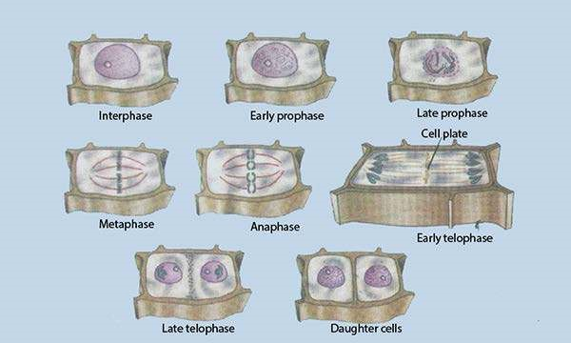

*Fig 21.3 Mitosis in a higher plant cell*

##### Importance of mitosis

In mitosis the hereditary material is equally distributed in the daughter cell. As there is no crossing over or recombination, the genetic information remains unchanged generation after generation, thus continuity of similar information is ensured from parent to daughter cell. Some organisms, both plants and animals, undergo asexual reproduction. Regeneration, healing of wounds and replacement of older cells all are the gifts of mitosis. Development and growth of multicellular organisms depends upon orderly, controlled mitosis. Tissue culture and cloning seek help through mitosis. For all this an organism requires managed, controlled and properly organized process of mitosis, which otherwise may result malfunction, unwanted tumors and lethal diseases like cancer.

### Cancer (uncontrolled cell division)

The multiplication of cells is so carefully regulated and responsive to speciic needs of the body, that process of cell death and birth are balanced to produce a steady state. Sometime the control, that regulates the cell multiplication, breaks down. A cell in which this occurs, begins to grow and divide in unregulated fashion without body’s need for further cells of its type. When such cells produce new cells which continue to proliferate in incontrolled fashion, an unwanted clone of cells, called tumor is formed, which can expand indeinitely. Tumors arise frequently, especially in older animals and humans, and are of two basic types. Some tumors are of small size and localized (not transferred to other parts) called benign. The cells in this type usually behave like the normal cells and have little deleterious efects,, only due to either its interference with normal cells or its hormone-like secretions.

*Fig: 21.4 result of meiosis,four haploid cells, each*

*with half as many chromosomes as the original cells.*

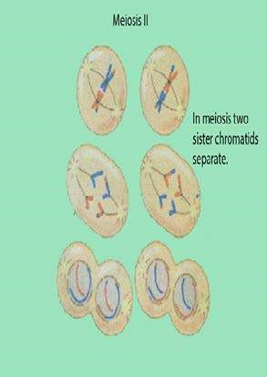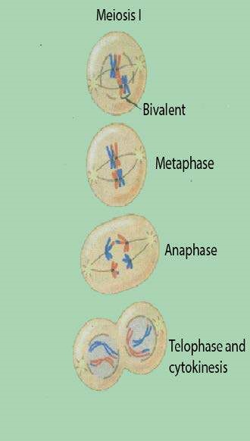

In contrast, the cells composing a malignant tumor or cancer, divide more rapidly, mostly invade surrounding tissues, get into the body’s circulatory system, and set up areas of proliferation, away from their site of original appearance. This spread of: tumor cells and establishment of secondary areas of growth is called as metastasis.

Cancer cells can be distinguished from normal cells because they are less diferentiated than normal cells, exhibit the characteristics of rapidly growing cells, i.e is, high nucleus to cytoplasm ratio, prominent nucleoli and many mitosis.

The presence of invading cells in otherwise normal tissue is an indication of malignancy. Cancer is caused mainly by mutations in somatic cells. Secondly, the cancer results from the accumulation of as few as three to as many as twenty mutations, in genes that regulate cell divisidn. These mutations bring two basic changes in the cancer cells. First, the metastatic cells break their contact with other cells and overcome the restrictions on cell movement provided by basal lamina and other barriers, ultimately metastatic cells can invade other parts of the body. Secondly, they proliferate, unlimitedly, without considering the checks or programmes of the body.

#### MEIOSIS

Meiosis is the special type of cell division in which the number of chromosomes in daughter cells is reduced to half, as compared to the parent cell. In animals at the time of gamete formation, while in plants when spores are produced. Each diploid cell after meiosis produces four haploid cells, because it involves two consecutive divisions after single replication of DNA. Two divisions, are meiosis I and meiosis II. The irst meiotic division is the reduction division, whereas second meiotic division is just like the mitosis. Both divisions can further be divided into substages like prophase 1, metaphase 1, anaphase 1, telophase 1 and same names are used for meiosis II also (Fig.21.4).

##### Prophase I

This is very prolonged phase, and difers from the prophase of mitosis, because in this chromosomes behave as homologous pairs. Each diploid cell has two chromosomes of each type, one member from each parent, because of fusion of male and female gametes. Each chromosome has two chromatids, because chromosomes have been replicated during interphase. The interphase of meiosis lacks G2 stage. These similar but not necessarily identical chromosomes are called as homologous chromosomes.

Prophase 1 further consists of the followings stages.

Leptotene:

The chromosomes become visible, shorten and thick. The size of the nucleus increases and homologous chromosomes start getting closer to each other.

**Zygotene:**  First essential phenomenon of meiosis i.e., pairing of homologous chromosomes called synapsis starts. This pairing is highly speciic and exactly pointed, but with no deinite starting point(s). Each paired but not fused, complex structure is called bivalent or tetrad.

**Pachytene:** The pairing of homologous chromosomes is completed. Chromosomes become more and more thick. Each bivalent has four chromatids, which wrap around each other. Non-sister chromatids of homologous chromosomes exchange their segments due to chiasmata formation, during the process called crossing over. In this way reshuling of genetic material occurs which produces recombinations. Pachytene may lasts for days, weeks or even years, whereas leptotene and zygotene can last only for few hours.

**Diplotene:** The paired chromosomes repel each other and begin to separate. Separation however, is not complete, because homologous chromosomes remain united by their point of interchange (chiasmata). Each bivalent has at least one such point, the chromatids otherwise are separated (Fig. 21.5).

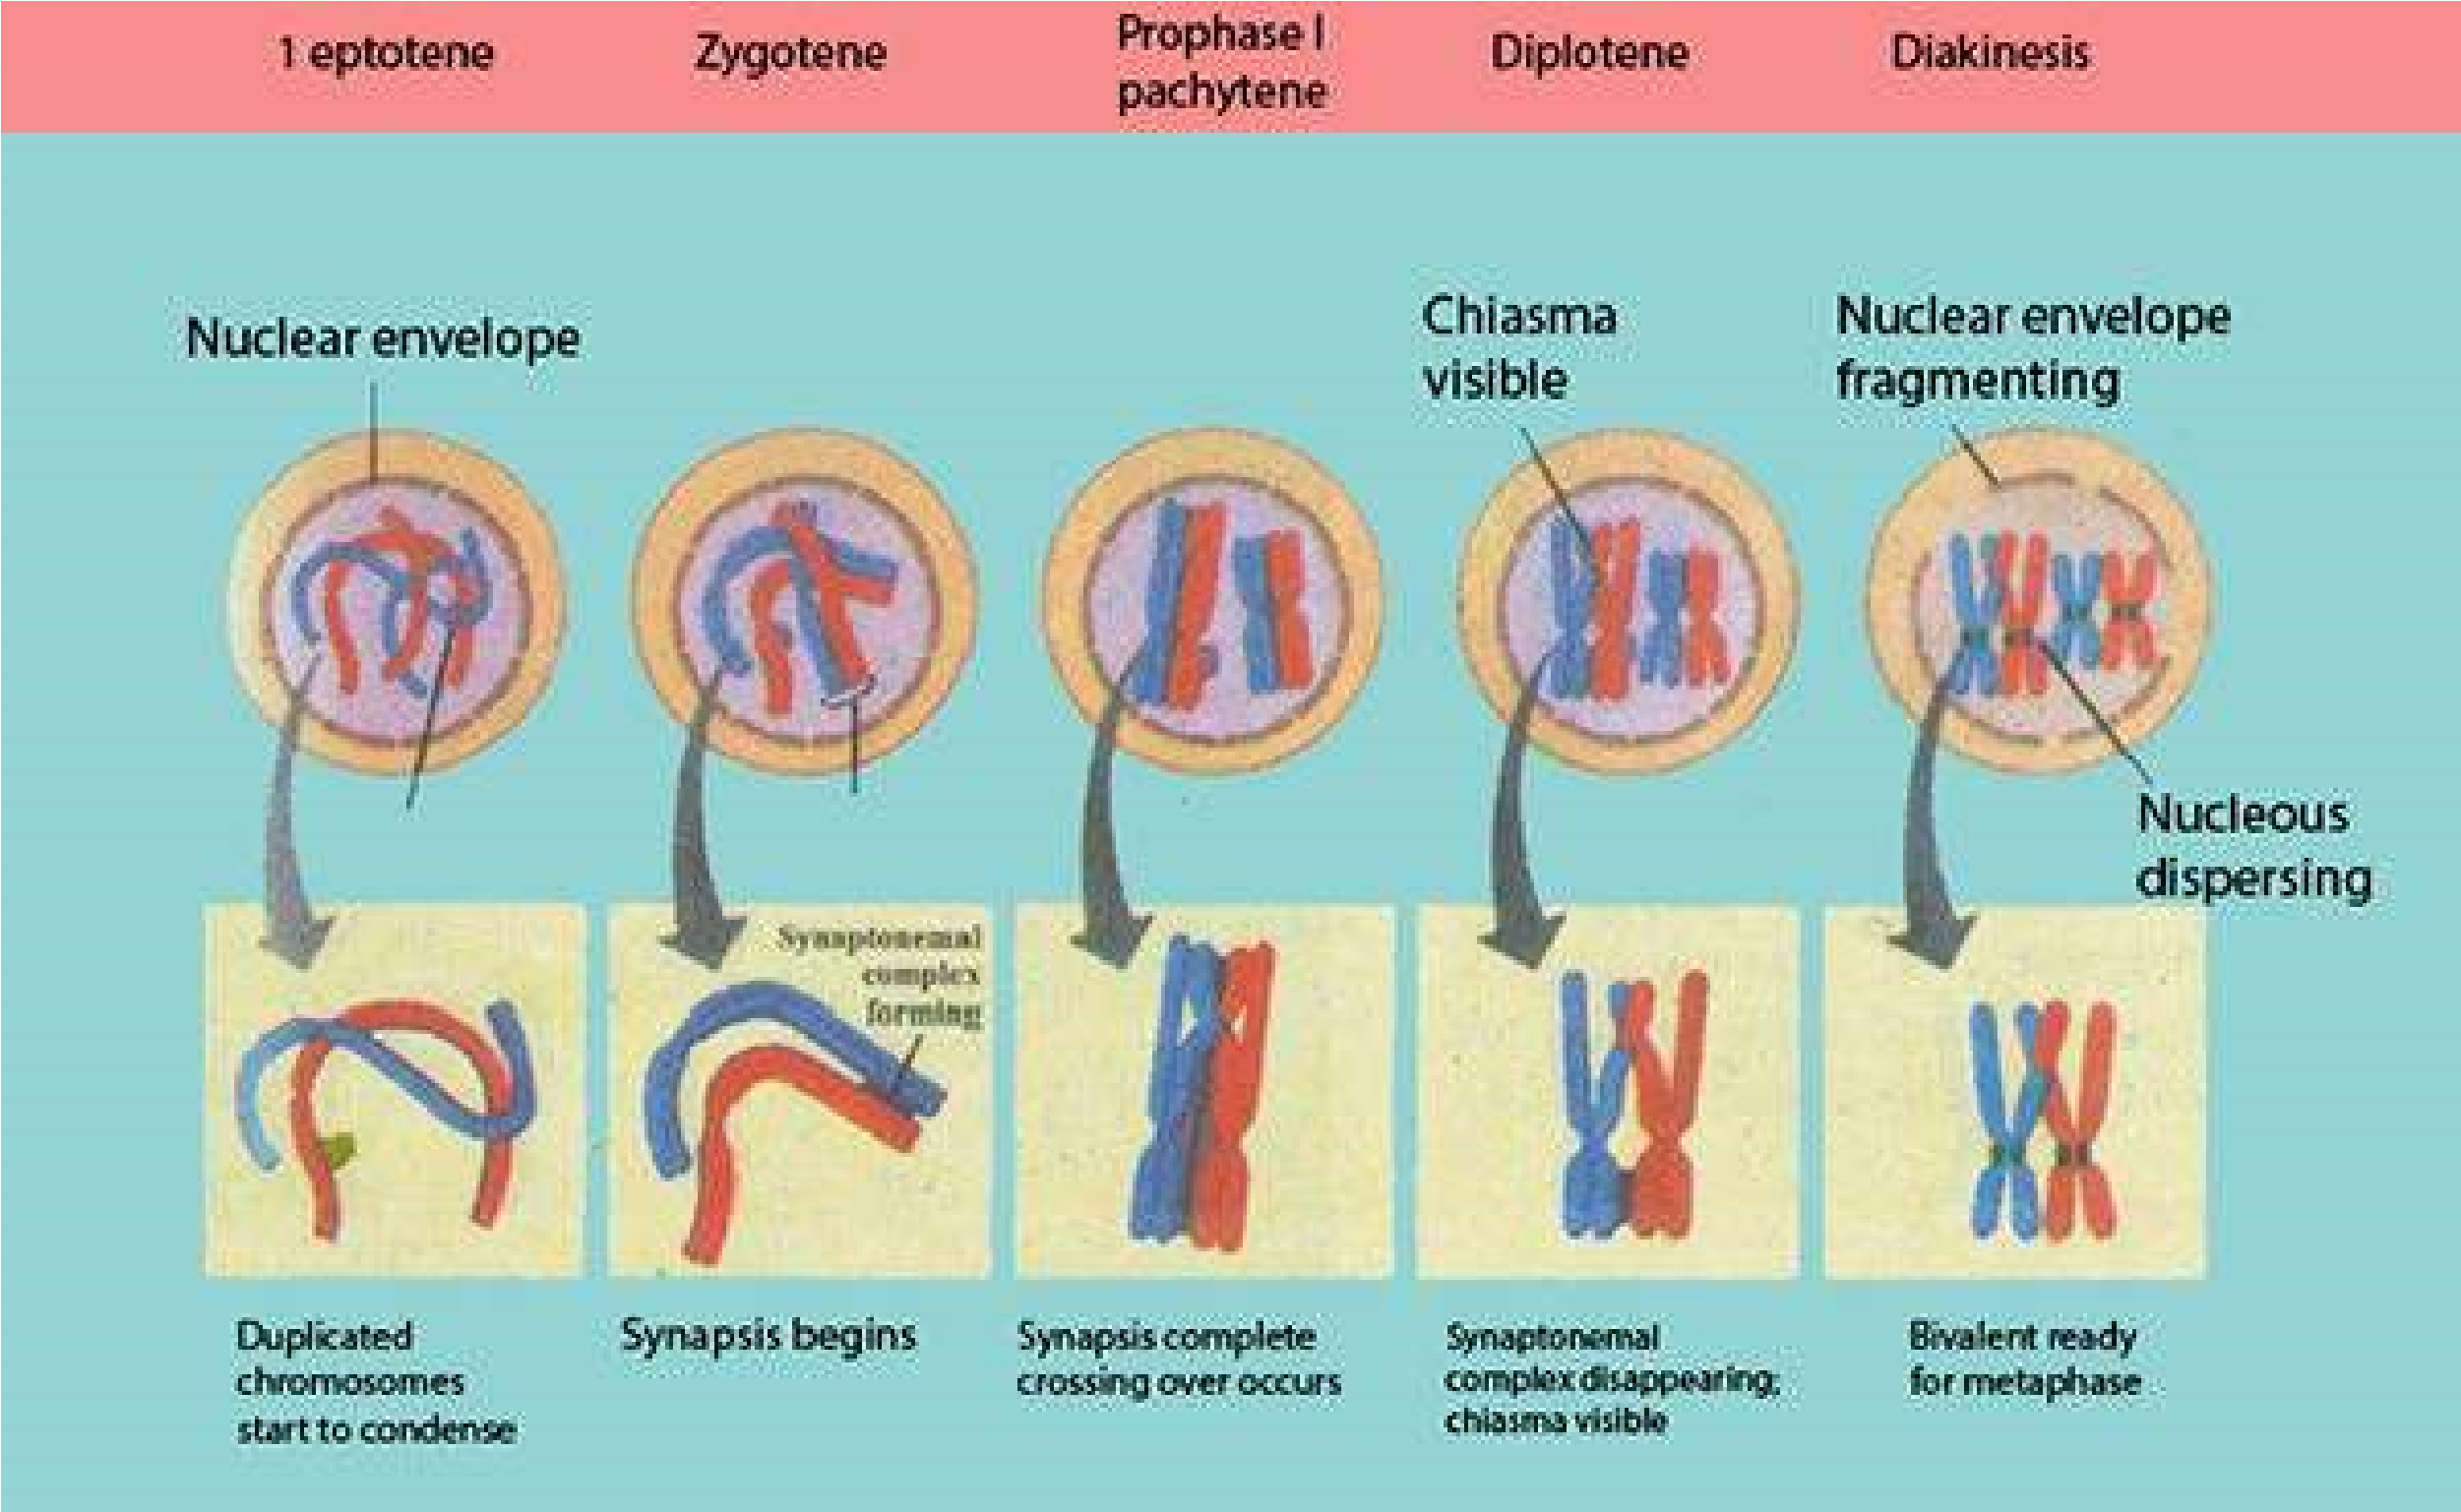

*Fig. 21.5 Chiasmata formation*

**Diakinesis:**  During this phase the condensation of chromosomes reaches to its maximum. At the same time separation of the homologous chromosomes (started during diplotene) is completed, but still they are united at one point, more often at ends. Nucleoli disappear.

##### Metaphase I

Nuclear membrane disorganizes at the beginning of this phase. Spindle ibers originate and the kinetochore ibers attach to the kinetochore of homologous chromosome from each pole and arrange bivalents at the equator. The sister chromatids of individual chromosome in bivalent behave as a unit.

##### Anaphase I

The kinetochore ibers contract and the spindle or pole ibers elongate, which pull the individual chromosome (each having two chromatids) towards their respective poles. It may be noted here that in contrast to anaphase of mitosis, sister chromatids are not separated. This is actually reduction phase because each pole receives half of the total number of chromosomes.

##### Telophase I

Nuclear membrane reorganizes around each set of chromosomes at two poles, nucleoli reappear thus two nuclei each with half number of chromosomes are formed, later on cytoplasm divides thus terminating the irst meiotic division. It is also to be noted that chromosomes may decondense during this stage.

##### Meiosis II

After telophase I two daughter cells experience small interphase, but in contrast to interphase of mitosis there is no replication of chromosomes.

Prophase II, metaphase II, anaphase II and telophase II are just like the respective phases of mitosis during which the chromosomes, condense, mitotic apparatus forms, chromosomes arrange at the equator, individual/sister chromatids move apart, and ultimately four nuclei at the respective poles of two daughter cells (formed after meiosis I) are formed. Cytokinesis takes place and four haploid cells, with half of the number of chromosomes (chromatids) are formed.

###### Importance of Meiosis

Crossing over and random assortment of chromosomes are two signiicant happenings of meiosis. During crossing over, parental chromosomes exchange segments with each other which results in a large number of recombinations. At the same time during anaphase the separation of homologous chromosomes is random, which gives very wide range of variety of gametes. Both these phenomena cause variations and modiications in the genome. These variations are not only the bases of evolution, but also make every individual speciic, particular and unique in his characteristics. Even the progeny of very same parents, i.e., brothers and sisters are not identical to each other.

Meiosis usually takes place at the time of sexual cell (gamete) formation, spore formation in plants, thus having the number of chromosomes in each, which is restored after fertilization and maintains chromosome number constant generation after generation. Had meiosis not been the process, the chromosome number may have been doubled after every generation. Can you imagine the consequences?

##### MEIOTIC ERRORS (NON-DISJUNCTION)

Meiosis is an orderly occurring phenomenon, which ensures every phase with appropriate inish, but some times, at any point the result may be unexpected, causing abnormalities.One of such abnormalities is chromosome non-disjunction, in which chromosomes fail to segregate during anaphase and telophase and do not inish with equal distribution of chromosome among all the daughter nuclei. This results either increase or decrease in the number of chromosomes, causing serious physical, social and mental disorders. This non-disjunction may be in autosome or in sex chromosome. Some examples of each type may be discussed below in some detail.

###### Down’s Syndrome (Mongolism)

It is one of the consequences of autosomal non-disjunction in man, during which 21st pair of chromosome fails to segregate, resulting in gamete with 24 chromosome. When this gamete, fertilizes normal gamete the new individual will have 47 (2n + 1) chromosomes. Non-disjunction appears to occur in the ova and is related to the age of mother. The chances of teenage mother having Down’s syndrome child is one in many thousands, forty years old mother, one in hundred chances and by forty-ive the risk-is three times greater. The afected individuals have lat, broad face, squint eyes with the skin fold in the inner corner, and protruding tongue, mental retardation, and defective development of central nervous system.

Autosomal non-disjunction may occur in other than 21st chromosome which usually results in abortion, or death in very early age.

###### Klinefelter’s Syndrome

These individuals have additional sex chromosome e.g., 47 chromosomes (44 .autosome + XXY). They are phenotypically male but have frequently enlarged breasts, ‘tendency to tallness, obesity, small testes with no sperms at ejaculation and under developed secondary sex characters.

Males with 48 chromosomes (44 autosomes + XXXY), with 49 chromosomes (44 autosomes + XXXXY) and with 47 chromosomes (44 autosomes + XYY) are also observed

(Fig. 21.6).

###### Turner’s Syndrome

These afected individuals have one missing X chromosome with only 45 •chromosomes (44 autosomes + X). Individuals with this condition often do not survive pregnancy and are aborted. Those who survive have female appearance with short stature, webbed neck, without ovaries and complete absence of germ cells.

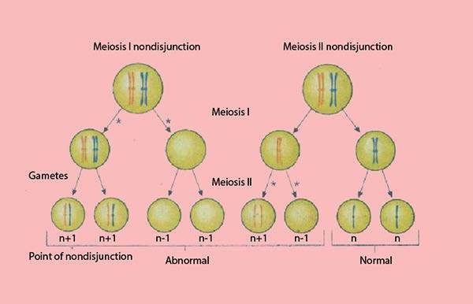

|  |  |  |  |  |
| --- | --- | --- | --- | --- |
| **Syndrome** | **Sex** | **Chromosomes** | **Frequency** | |
| **Abortions** | **Births** |
| Down | M or F | Trisomy 21 | 1/40 | 1/700 |
| Patau | M or F | Trisomy 13 | 1/33 | 1/15,000 |
| Edward | M or F | Trisomy 18 | 1/200 | 1/6,000 |
| Turner | F | XO | 1/18 | 1/6,000 |
| Metafemale | F | XXX or (XXXX) | 0 | 1/1,500 |
| Klinefelter | M | XXY or (XXXY) | 0 | 1/1,500 |
| Jacobs | M | XYY | ? | 1/1,000 |

*Fig. 21.6 Non-disjunction of autosomes (a) Non disjunction occurring during meiosis I and meiosis* II*, gametes (asterisks mark points of non-disjunction), (b) Frequency of syndromes*

### Necrosis and Apoptosis

Cells in an organism depend upon various extracellular and intracellular signals for its regulated, controlled activities like cell division, pattern formation, diferentiation, morphogenesis and motility. Each cell is predestined to its fate i.e., what responsibility it has to take and in which way. Even the death of the cell is programmed.

Programmed cell death helps in proper control of multicellular development, which may lead to deletion of entire structure (e.g., the tail of developing human embryos) or part of structure (e.g., tissue between developing digits). Cell death even controls the number of neurons, because most of the neurons in the human body die during development.

Cell death in multicellular organisms is controlled by two fundamentally diferent ways, i.e., either the cell commits suicide in the absence of survival signals (trophic factors) or cells are murdered by killing signals from other cells.

Internal programme of events and sequence of morphological changes by which cell commits suicide is collectively called as apoptosis (Greek word that means dropping of or falling of).

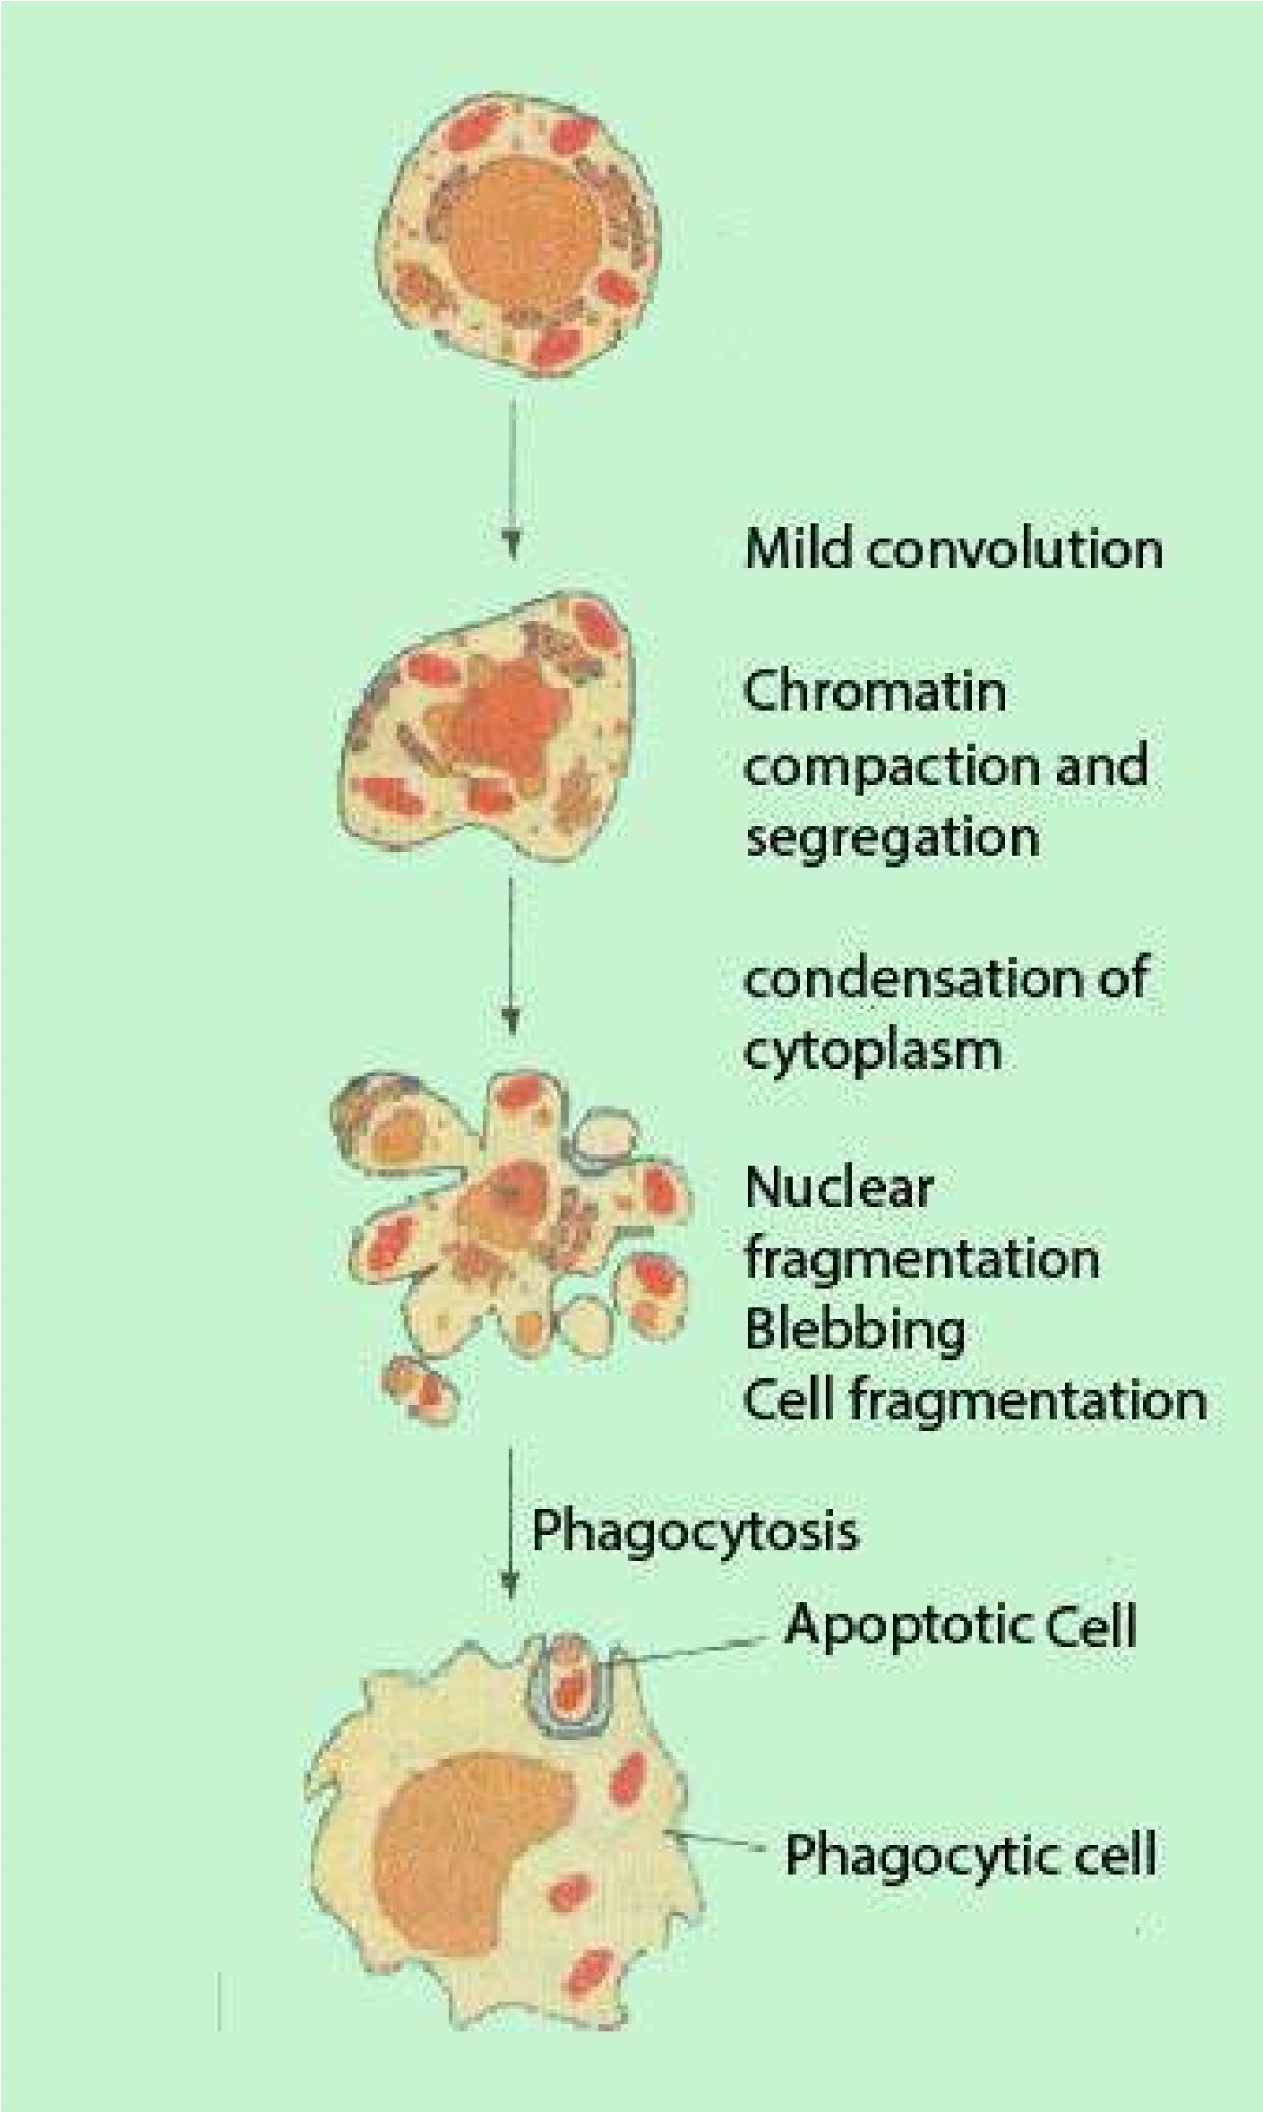During this process the dying cells shrink and condense ultimately split up, thus releasing small membrane bounded apoptotic bodies, which are generally phagocytosed by other cells (Fig.21.7). Intracellular constituents are not released freely in extracellular atmosphere which otherwise might have deleterious efects. In contrast to suicide, the cell death due to tissue damage is called necrosis, during which the Fig21.7 typical cell swells and bursts, releasing the intracellular contents, which can damage neighbouring cells and cause inlammation.

*Fig: 21.7 Ultrastructural features of cell death by apoptosis*

#### EXERCISE

**Q.1 Fill in the blanks.**

1. Mongolism is also known as_______ .
2. During_______ homologous chromosomes get close to each other.
3. ________phase precedes G2 phase.
4. Polar microtubules during anaphase.
5. Mitotic apparatus is formed during_______ of cell division.
6. The chromosome number (44+1) denotes______Syndrome.
7. Intracellular contents are released during the type of cell death called ---------.

**Q.3 Write true / false against each statement, if It is false, rewrite tfhettmie statement**

1. Meiosis occurs in haploid cells only.
2. Cell cycle is comprised of two phases i.e. karyokinesis and cytokinesis.
3. A point where non-sister chromatids cross each other is called kinetochore.
4. G0 stands for no gap,
5. Full life cycle of yeast cells require 90 seconds to be completed.
6. Crossing over takes place during metaphase I.
7. Autosomal non disjunction may occur in chromosomes other than 21st chromosome,
8. Benign tumors are always non localized,
9. Cancer is caused mainly by mutations in germ cells.
10. Genetic informations remain unchanged during mitosis.
11. Homologous chromosomes are necessarily identical.
12. The cells are kept alive due to trophic factors.
13. Cytokinesis involves the division of cytochromes.
14. Phragmoplast is a type of fragmentation.

**Q.4. Short questions**

1. Diferentiate between necrosis and apoptosis.
2. What are the functions of mitotic apparatus?
3. How can you identify the cancer cells?
4. Give importance and signiicance of meiosis.
5. Deine chromosomal non disjunction.
6. What are symptoms of turner’s syndrome?
7. Deine cell cycle. Highlight its importance and signiicance.
8. Is interphase a resting phase? Why?
9. In what respect does mitosis in plant cells difer from that in animal cells?

**Q3. Extensive questions.**

1. How does cytokinesis occur in animals cells? In which way does it difer from that in plant cell?
2. Why and how do the chromosomes get separated during anaphase of mitosis?
3. What is the role of centriole in an animal cell? How is this function carried out in plant cell?
4. In what respect can cell death be regarded beneicial?
5. Compare mitosis with meiosis and describe their importance.
6. Deine disjunction and discuss its efect.
7. Describe meiosis and explain its signiicance.